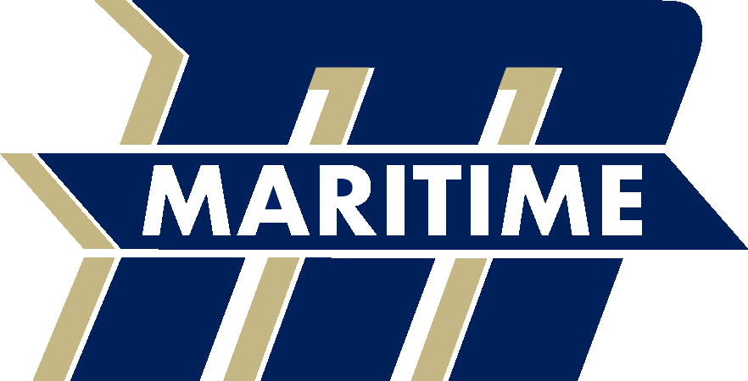
2019 Massachusetts Maritime Academy Buccaneers
Women’s Cross Country Roster

Name
Patrick Brown Fr
Douglas Cleary Sr Pocasset, Mass / Upper Cape Tech
William Deboer Jr Hanover, Mass / Hanover
Michael Fappiano Fr
Zach Ferreira Jr Stoughton, Mass / Stoughton
Kyle Hansen Sr North Chelmsford, Mass / Chelmsford
Alex Imperillo Jr Chelmsford, Mass / Chelmsford
Lukas Janulaitis Fr
Esmael Mendes Sr Cataumet, Mass / Bourne
Daniel Plumb Sr Hopkinton, Mass / Hopkinton
Nathan Remillard So East Falmouth, Mass / Saint John Paul II
Daniel Ryan Jr Hanover, Mass / Hanover
Steven Savoy Sr West Bridgewater, Mass / West Bridgewater
Ben Tuttle Fr

Head Coach – Chris Slattery
Assistant Coach – Anton Smith

